Sire Inspection Module
A Quick Guide

1. Sire Inspection Reports

These reports will display the data related to the Sire Audit. There are 13 reports in this module divided into 4 sections.
To Navigate to this module login into BI instance using the below url.
http://192.168.166.203:9704/analytics/saw.dll?bieehome&startPage=1

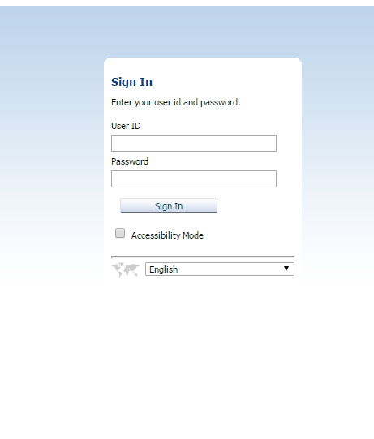

Enter the below Credentials
User ID : Operations
Password : welcome1

Once Logged in then navigate to the dashboards and select Bunker Supplier Analysis Dashboard

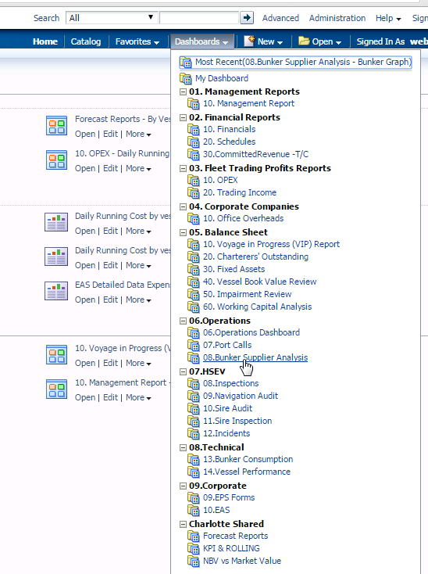

    - There are 2 dashboards under this module
        - Supplier Analysis
        - Port Analysis

- Bunker Graph displays the Qty and Cost of Planned,Supplied,Invoiced and paid for the supplier
There are 2 prompts for the report
- Stem Date : Dates for which the data needs to be fetched.
- Type : Type Of the bunker (HSFO,LSFO,HSDO,LSDO)

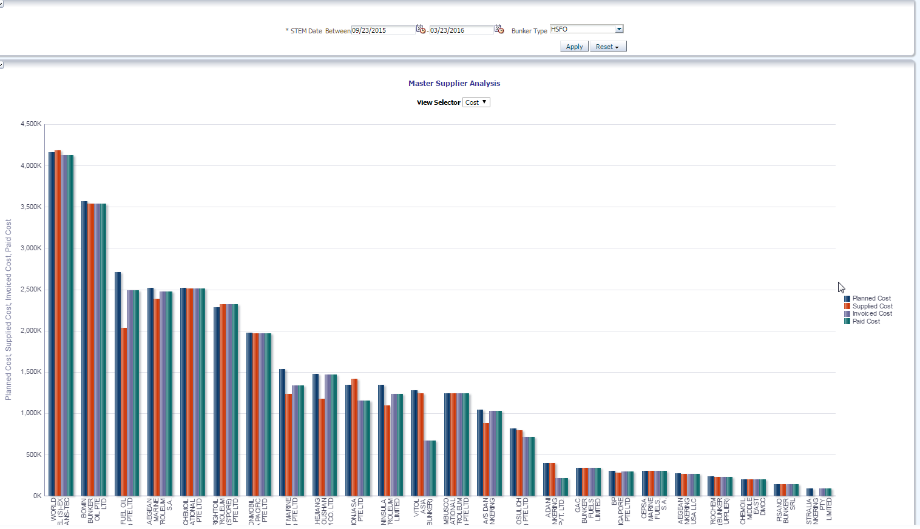

When clicked on supplier name another detailed report opens up.

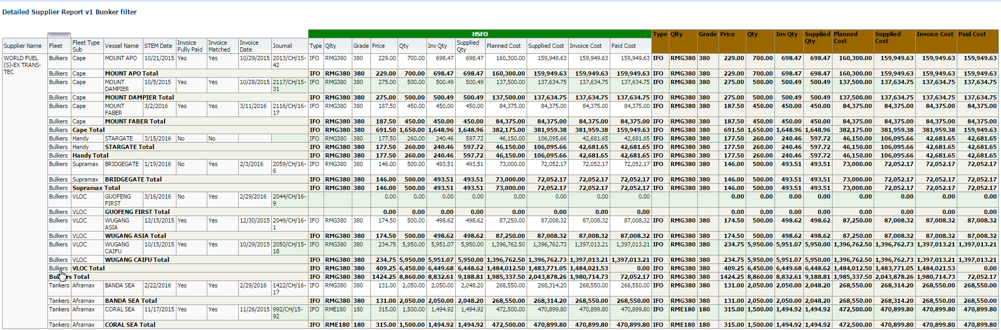

- Port Analysis displays the Trend analysis across the Top 20 ports and Countries for Qty and Average Cost of Planned,Supplied,Invoiced in separate graphs.
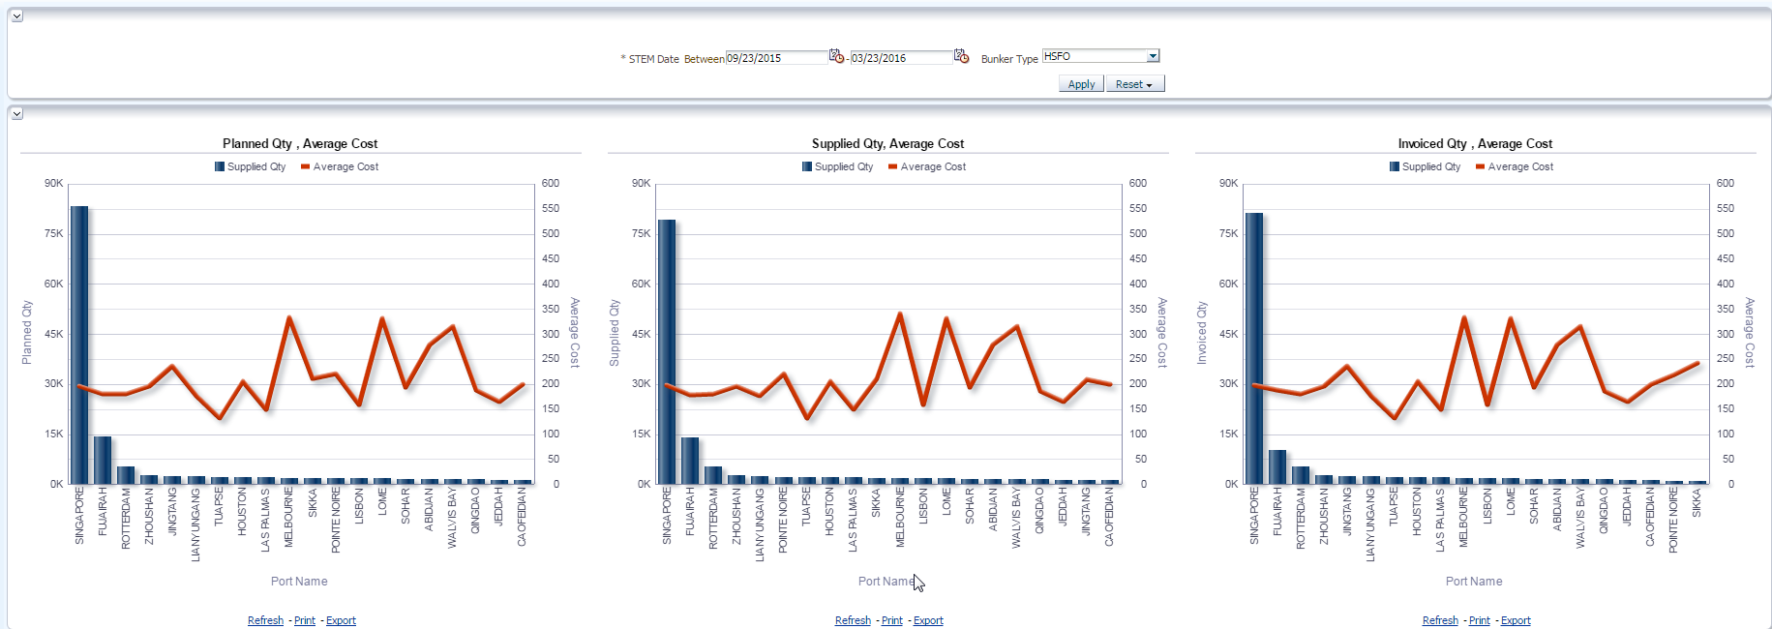

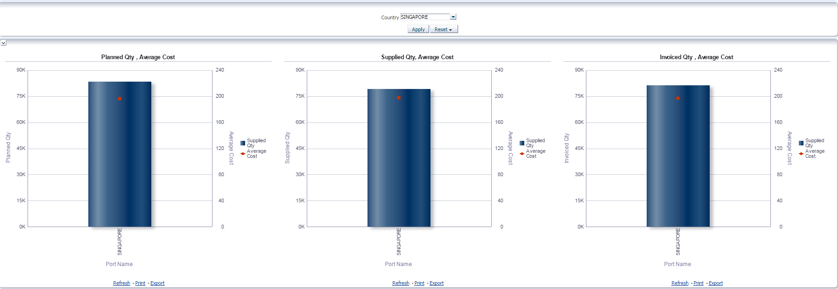
When clicked on the portname then another report with supplier information in that port displays
